Wednesday, June 5, 2024
4 – 8 p.m.
Henry Ford Hospital, E&R Tennis Court

We are thrilled to welcome you to join us as a chef at Henry Ford Hospital’s popular taste fest. Everyone Who Cooks, traditionally composed of male chefs, is
excited to invite everyone to participate.
Please join us for this fun-filled event that showcases the culinary talents of ALL employees from Henry Ford Health and partner companies across Southeastern Michigan.

Henry Ford team members and families, alongside our corporate partners are invited to support this year’s event and participate in a fabulous live auction and package raffle, while enjoying great food, drinks, entertainment and so much more.

Everyone Cooks supports the Tom Groth Patient Medical Needs Fund, a lifeline between Henry Ford Health and thousands of people from Southeast Michigan facing serious health problems by providing medications, transportation, equipment, medical supplies and social services.

Event Schedule

12:00 – 3 p.m. Chefs arrive for set up/prep/cooking

4 – 5 p.m. Judging and VIP reception
5 p.m. General admission opens

6:15 p.m. Sponsor recognition, awards presentation, live auction

7 p.m. Package raffle winning tickets drawn

8 p.m. Event ends

Calling ALL Chefs!
Everyone Who Cooks invites YOU to join us!


Show your love for all things
Tailgate Party Theme!

Themed dishes, costumes and table decorations are encouraged.

Judges will give awards to the best:
- Appetizer
- Entrée
- Dessert
- Costumes/Table Décor
- LiveWell Award-see pg. 4 for more info

CHEF INFORMATION
Please read carefully

- There will be a Chef Check-in/Check-out Service Area to ensure that you receive the supplies you ordered and return what should be returned. Please be VERY specific as to what you are bringing with you and what you need. Supplies (and space) are limited and ordered prior to the event based on what is requested.

- Each chef team will receive ONE eight-foot table to serve from and ONE eight-foot table behind their table for prep. Space is limited and additional tables and/or space will not be provided the day of the event.

- This is a tasting; only serve bite-size portions (Recommended: 400-600 servings or more of 1-2 ounce. portions, no more than 1-2 bites).

- 10 Grills are available and are assigned on a first come, first serve basis. Propane tanks will be provided.

- Please reference the Chef Commitment Form (below) for supplies we can provide. Only certain items are available. Supplies such as serving spoons, knives, cutting boards, can opener, blenders, grilling utensils etc. will not be provided. You are responsible for all other equipment and serving materials not offered.

- You will need something to serve your food from. Remember to include chafing dishes on your order if you need to keep food warm. If you request chafing dishes, please request gas burners (2 burners required per chafing dish).

- To facilitate timely cleanup, please complete all cooking by 7:30 p.m. Please clean your area, you will be required to check-out with a chef runner before departure to ensure all rental equipment is accounted for.

- If the occurrence of event cancelation, HFH will not be responsible for reimbursement of any materials, supplies, or ingredients purchased by individual chefs or teams.

Chef Participation

Who can participate as a chef?
- ANY Henry Ford Health team member or corporate representative of partner companies (chefs are no longer required to be male- everyone is invited to participate)
- Individual chefs or chef teams
- Please limit chef teams to a maximum five chefs due to space

What you need to prepare:
- 400 servings (or more) of 2 to 3.5-ounce portions (tasting size - no more than 2 bites)
  - No alcohol can be served at your chef stations

When and where we need you:
- Wednesday, June 5, 2024
- Henry Ford Hospital’s Main Campus, E & R Tennis Court
- Chef check-in and set-up begins at 12:00 p.m.
- Be ready for judging and the VIP reception at 4:00 p.m.
- Event opens for general admission at 5:00 p.m.
- Chefs DO NOT need a ticket for the event

How to sign-up:
- Complete Chef Commitment Form. Please complete all required data before submitting. Only one form is required per team. Please write LEGIBLY as information and team members names will be transferred to day of signage.

Deadline: Friday, May 10, 2024

Serving Supplies Provided:

*We are only able to provide what is requested by chefs on
Chef Commitment Form please be specific *
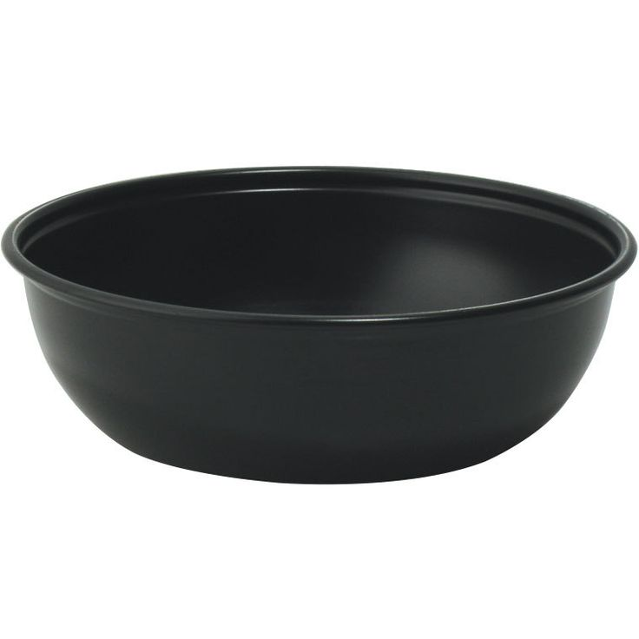

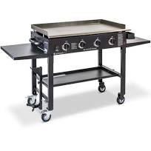

bowl

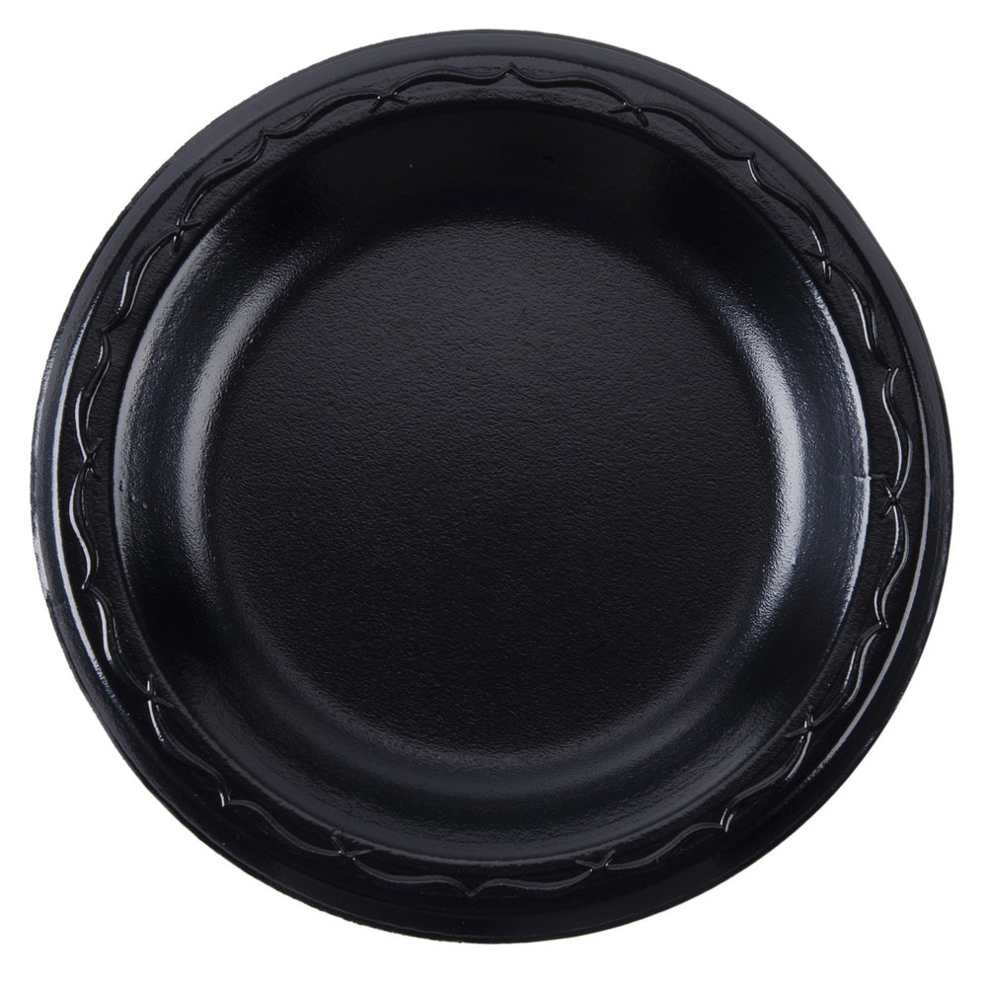
Gas Grill with propane
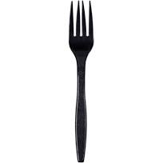
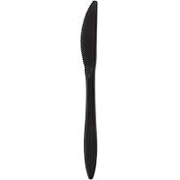
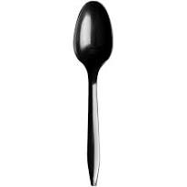
round plate

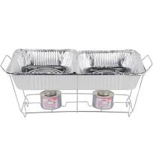
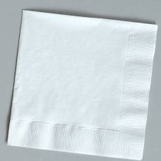
Forks, Knives, Spoons, Napkins

Chafing dishes and burners
(2 burners required per dish-please specify on commitment form)



You’re invited to enter as a LiveWell Chef Team!

To qualify, your dish should have:
- less than 10% calories from saturated fat
- less than 200 mg sodium per serving for appetizers/side dishes
- less than 500 mg sodium per serving for main entrée

Email your recipe to see if it’s LiveWell approved! Recipes must be submitted and include approximate breakdown of ingredients and serving size/number of servings no later than Friday, May 17, 2024

Need help getting started? Try these LiveWell approved recipes, which feature how-to videos:

- Oven-Fried Chicken Bites
  - http://www.henryfordlivewell.com/oven-fried-chicken-bites-with-tangy-dill-dip/
- Apple Walnut Bread
  - http://www.henryfordlivewell.com/apple-walnut-bread-recipe-video/
- Cocoa-Date Truffles
  - http://www.henryfordlivewell.com/cocoa-date-truffles/
- Heart Smart Guacamole
  - http://www.henryfordlivewell.com/easy-heart-smart-guacamole-recipe/
- Jicama-Mango Salad with Spicy Lime Vinaigrette
  - http://www.henryfordlivewell.com/jicama-mango-salad-recipe-video/
- Fish Tacos with Avocado Cilantro Sauce
  - http://www.henryfordlivewell.com/fish-tacos-avocado-cilantro-sauce/
- Vegetarian Stuffed Mushrooms
  - http://www.henryfordlivewell.com/vegetarian-stuffed-mushrooms-recipe/
- Chicken Fajitas
  - http://www.henryfordlivewell.com/video-sheet-pan-chicken-fajitas-recipe/
- Southwest Salad with Creamy Sriracha
  - http://www.henryfordlivewell.com/video-southwest-chopped-salad-with-creamy-sriracha-dressing

All recipes must be submitted to alidste1@hfhs.org for approval no later than Friday, May 17, 2024

CHEF COMMITMENT FORM
Deadline: Friday, May 10, 2024
Please return forms to Amber Lidster at alidste1@hfhs.org

Team Name:
Team Captain:
Additional Team Member Name(s):
Department(s) or Company Name:
Email: Event Day Phone:
I have participated as a chef for the last _____ year(s)

CHEF TEAM SUPPLY REQUESTS
*Please be VERY specific as to what you are bringing with you and what you need. Supplies are limited and ordered prior to the event based on what is requested.
Additional space/supplies/tables will not be available the day of the event*

Name of your dish:
Category that best describes your dish:

❑ Appetizer  Entrée  Dessert

I am entering to be in the LiveWell Award category:

❑ Yes (recipe attached to be analyzed)  No

Serving containers Needed:

❑ bowls  plates  None

Serving Utensils Needed:

❑ Forks  Spoons  Knives  None

*Hand cleaning supplies, additional sanitizing stations, and sanitizer will all be provided

Cooking Equipment Needed:

Chafing Dishes Needed: Gas Burner (2 per chafing dish):

Extension Cord(s) Qty.  Grill

Please list any additional cooking equipment you are bringing that needs floor and/or table space: __________________________________________________________________________________________________________________________________________________________________________________________________________________________________________________

** All ingredients and cooking utensils to be provided by Chefs**

How to receive a tax-deductible receipt for the food and supplies you purchased:

• Save your receipts

• Complete and submit the Gift-In-Kind form below. You must complete and sign the form and attach receipts to receive a non-cash contribution receipt.

• Forms due to Amber Lidster (alidste1@hfhs.org) by Friday, October 4, 2024

Thank you for your support!

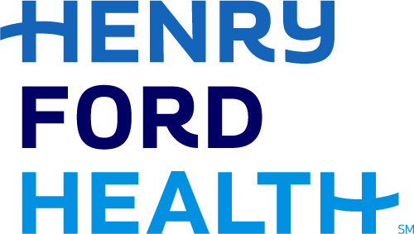
Development Office
Gift In-Kind [GIK] Contribution Form

1 Ford Place, 5A Tax ID #: 38-1357020
Detroit, MI 48202-3450

Donor Name: Gift Date:

Address:

City: State: Zip:

Phone: E-mail:

Detailed Description of Contribution:

Donor’s Estimated Fair Market Value of Contribution:
Signature of Donor: Date:
[Required if donor does not provide documentation on the value of their gift in the form of an invoice, letter]

*Note to Donor:
Henry Ford Health System gratefully acknowledges your in-kind contribution. This contribution is accepted, without reservation, for Henry Ford Health System’s use, resale, or disposal. Henry Ford Health System has not provided any goods or services to you in consideration for your contribution.

The following information pertaining to your in-kind contribution is being provided for your convenience and does not constitute legal advice on behalf of Henry Ford Health System or their employees. You are strongly encouraged to consult your tax advisor and refer to the IRS guidelines.

To claim a tax deduction for in-kind gifts valued…

- Less than $500, refer to IRS Form 1040, Schedule A.
- Between $500 and $5,000, the donor must complete Part 1 of IRS Form 8232.
- $5,000 or greater, the donor must:
- Complete ALL parts of IRS Form 8232 and submit the completed form to the Henry Ford
Health System Office of Philanthropy for signature.
- Submit a certified appraisal dated no more than 60 days from the date of the donation. The appraisal must be prepared, signed and dated by a qualified, third-party appraiser.

The value of any item, regardless of the amount, is used for internal gift reporting purposes only – Henry Ford Health System is unable to include the estimated value on a donor receipt. It is the responsibility of the donor to substantiate the fair market value for their own tax purposes.

HFH Development Representatives: Amber Lidster
Email/ Phone: alidste1@hfhs.org, 313-314-0871
Appeal/Program: 24MWC/2210

